Test Case: runTestMultipleTimes
Step 1 - Enter username and password and click to button Enter : Credentials Entered
Image file-name: QC_Testing-runTestMultipleTimes-dic. 04 2025, 03 52 49 p. m.

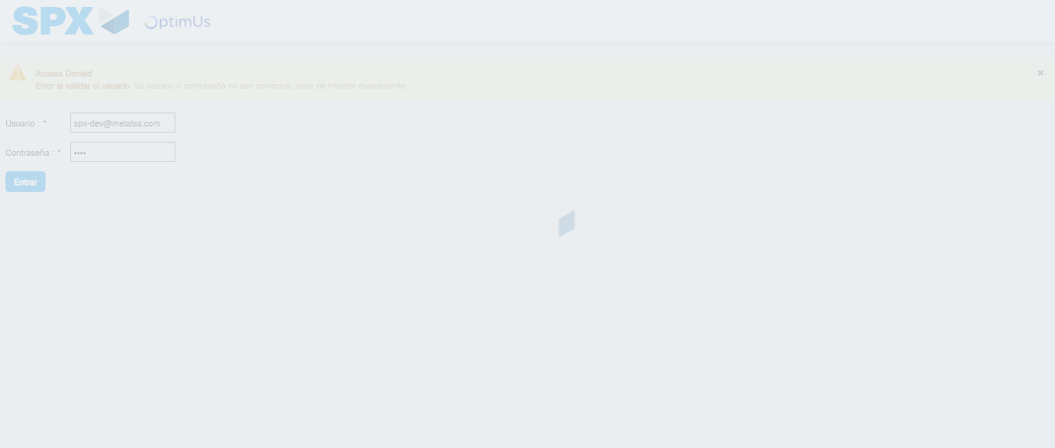Image file-name: QC_Testing-runTestMultipleTimes-dic. 04 2025, 03 52 50 p. m.

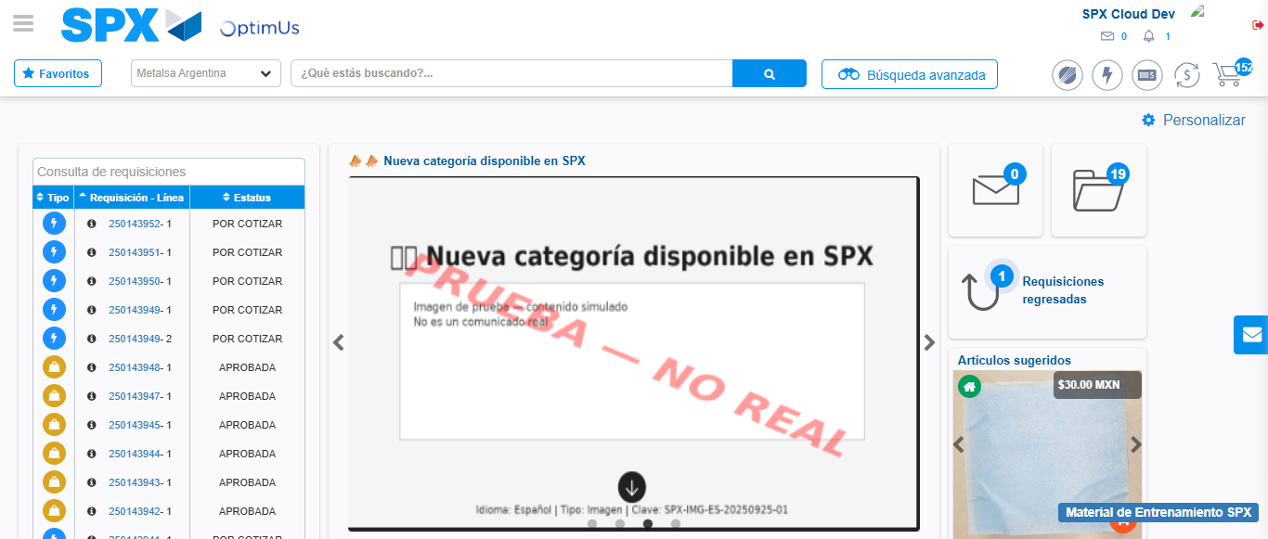Image file-name: QC_Testing-runTestMultipleTimes-dic. 04 2025, 03 54 40 p. m.

Step 2 - Select to UEN and Access to Spot Buy Requisitions : UEN Correctly selected and Correct access
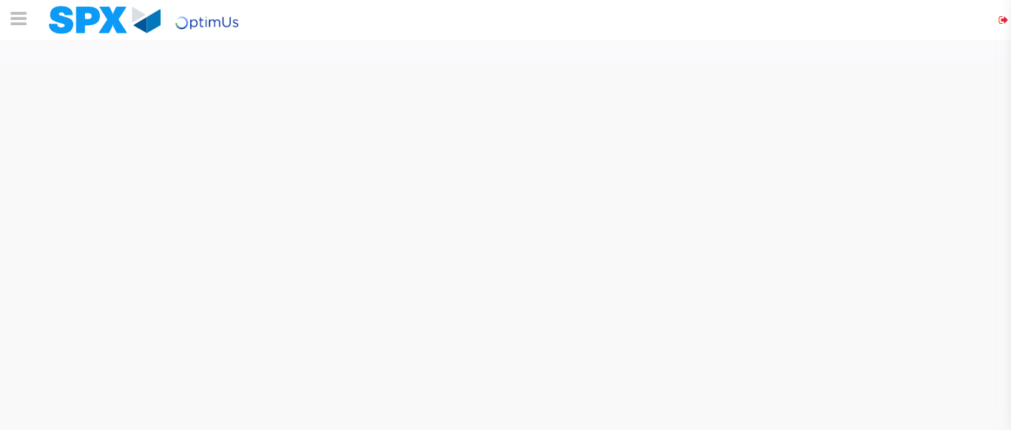Image file-name: QC_Testing-runTestMultipleTimes-dic. 04 2025, 03 52 54 p. m.

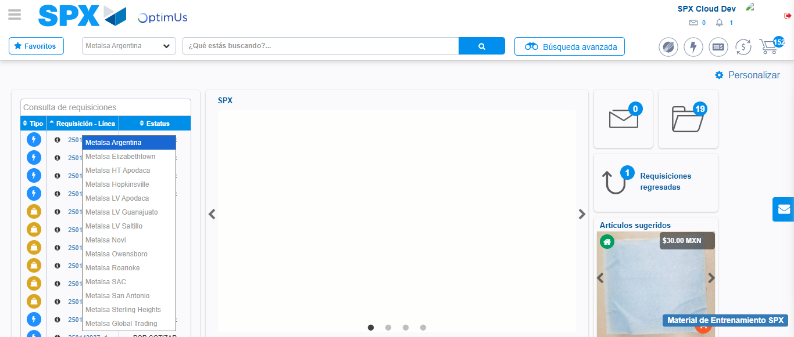Image file-name: QC_Testing-runTestMultipleTimes-dic. 04 2025, 03 52 55 p. m.

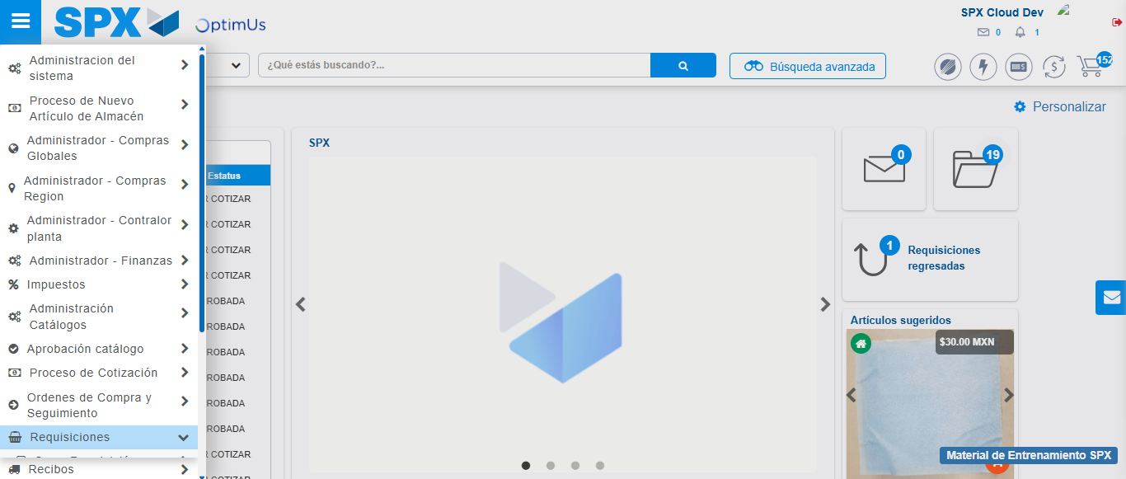Image file-name: QC_Testing-runTestMultipleTimes-dic. 04 2025, 03 52 56 p. m.

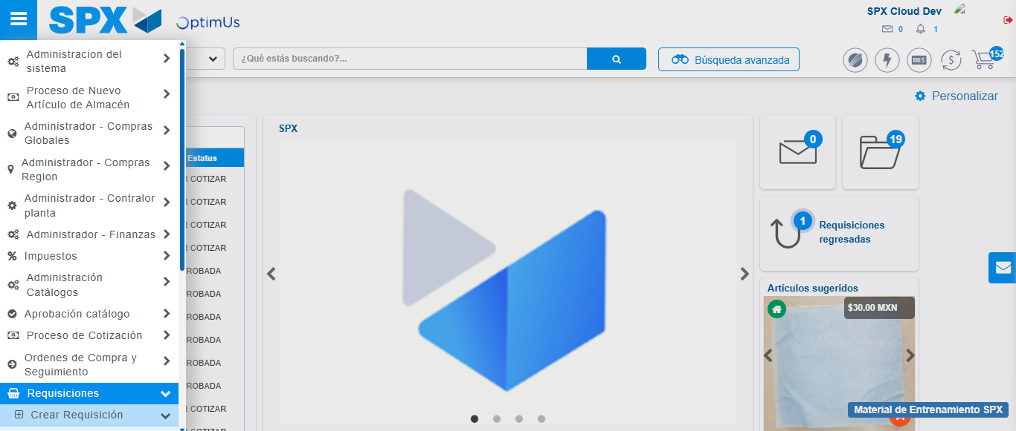Image file-name: QC_Testing-runTestMultipleTimes-dic. 04 2025, 03 52 57 p. m.

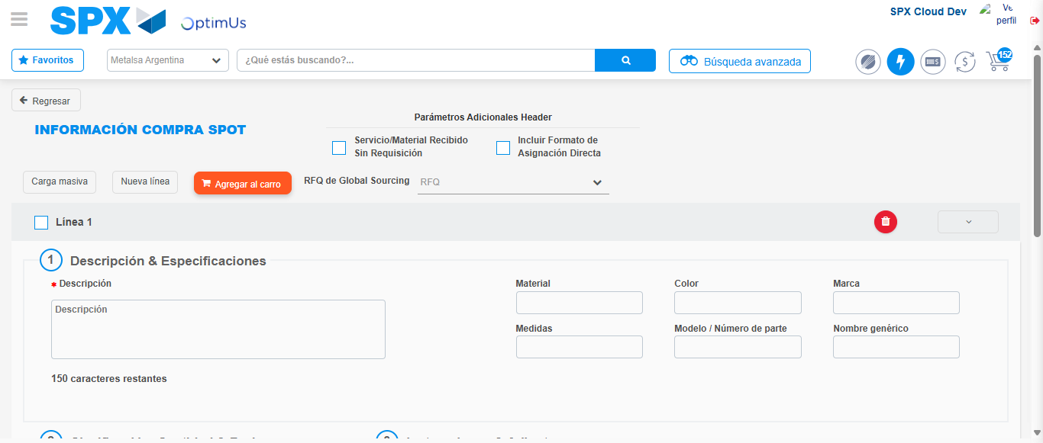Image file-name: QC_Testing-runTestMultipleTimes-dic. 04 2025, 03 53 08 p. m.

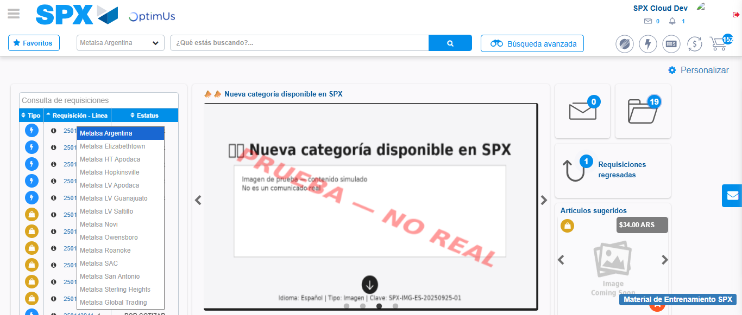Image file-name: QC_Testing-runTestMultipleTimes-dic. 04 2025, 03 54 41 p. m.

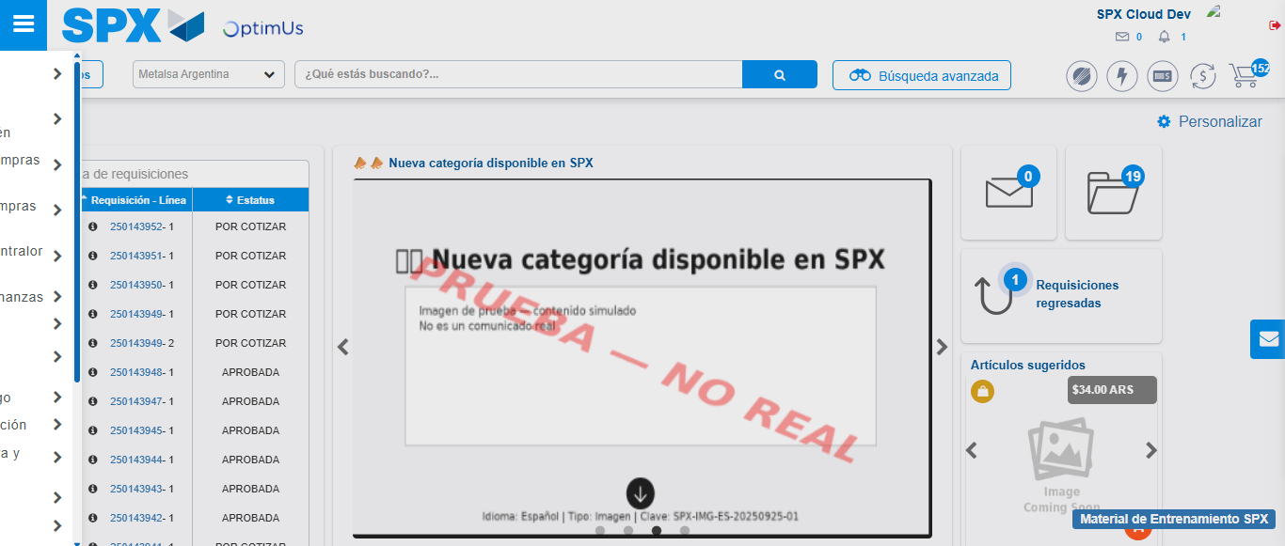Image file-name: QC_Testing-runTestMultipleTimes-dic. 04 2025, 03 54 42 p. m.

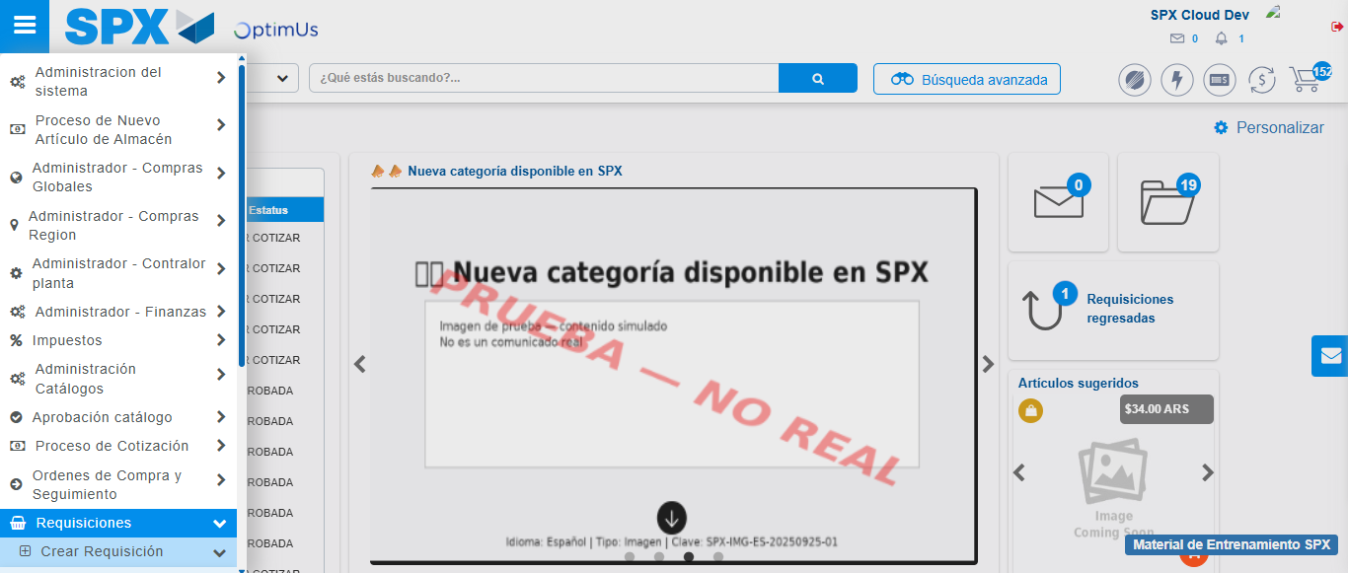Image file-name: QC_Testing-runTestMultipleTimes-dic. 04 2025, 03 54 43 p. m.

Image file-name: QC_Testing-runTestMultipleTimes-dic. 04 2025, 03 54 46 p. m.

Step 3 - Data Capture Spot Buy Requisition : Data captured correctly
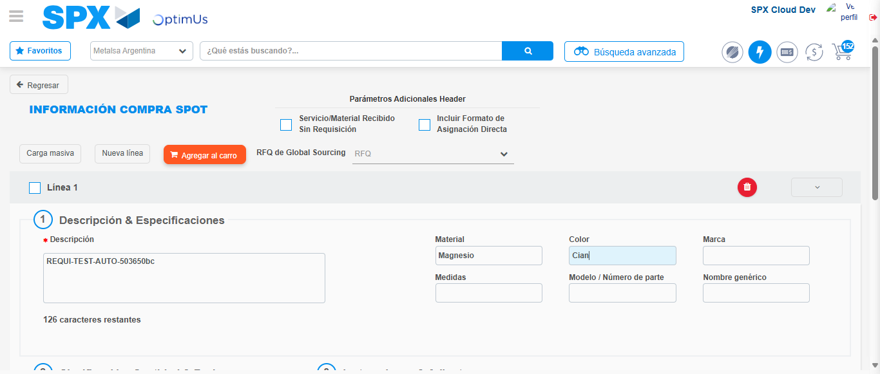Image file-name: QC_Testing-runTestMultipleTimes-dic. 04 2025, 03 53 09 p. m.

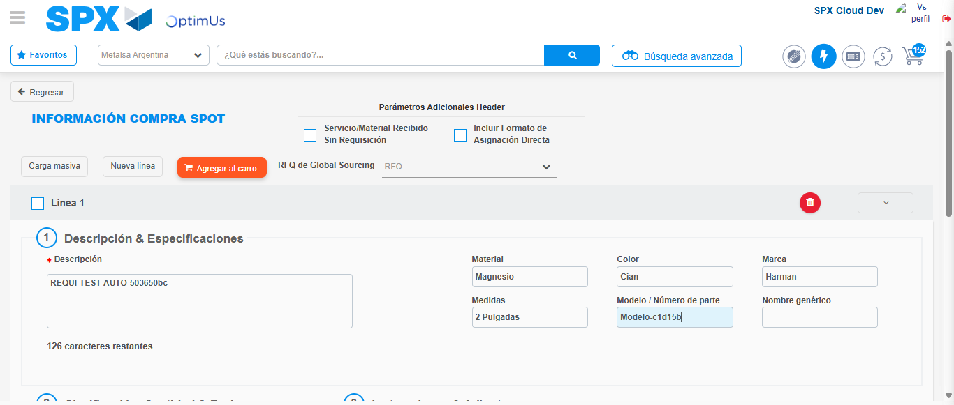Image file-name: QC_Testing-runTestMultipleTimes-dic. 04 2025, 03 53 10 p. m.

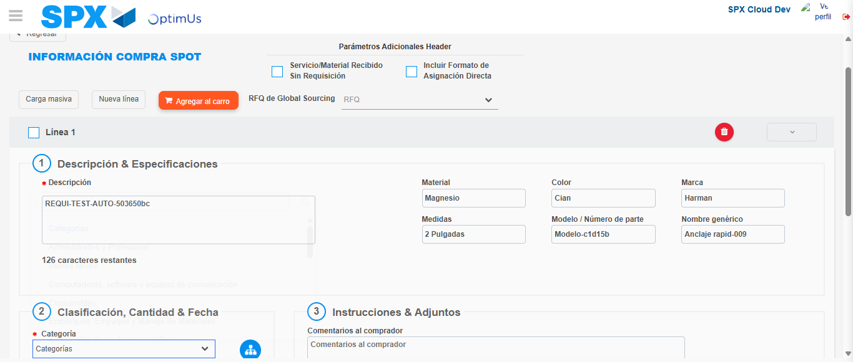Image file-name: QC_Testing-runTestMultipleTimes-dic. 04 2025, 03 53 11 p. m.

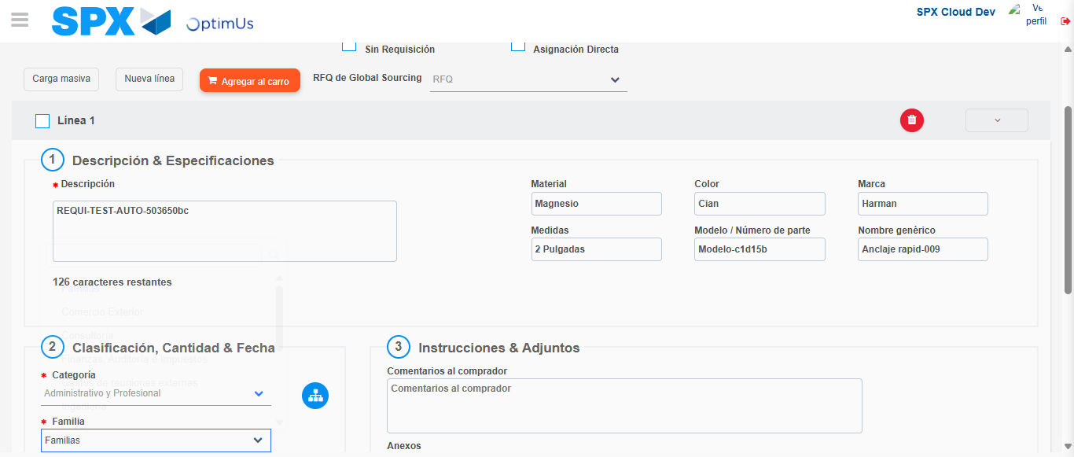Image file-name: QC_Testing-runTestMultipleTimes-dic. 04 2025, 03 53 12 p. m.

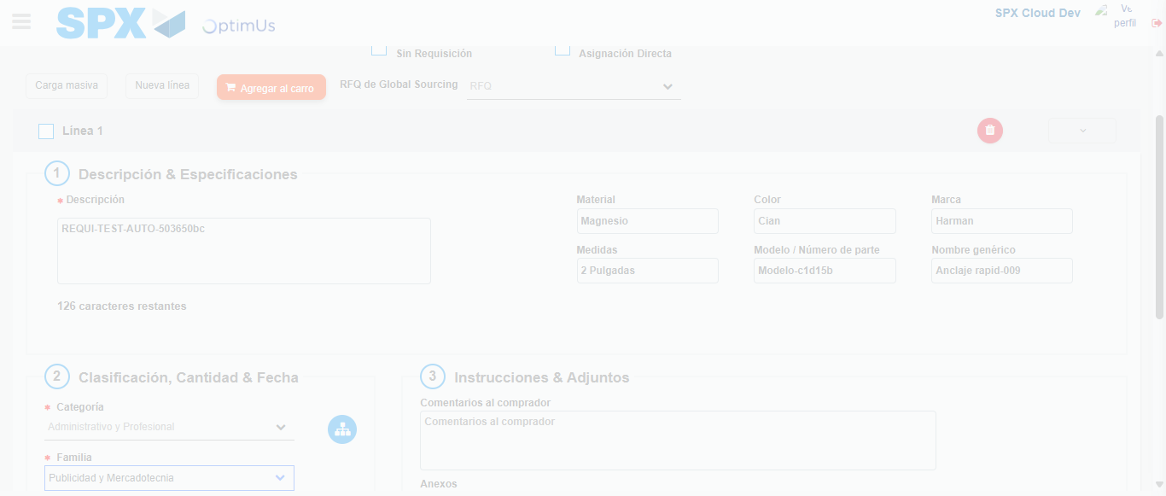Image file-name: QC_Testing-runTestMultipleTimes-dic. 04 2025, 03 53 13 p. m.

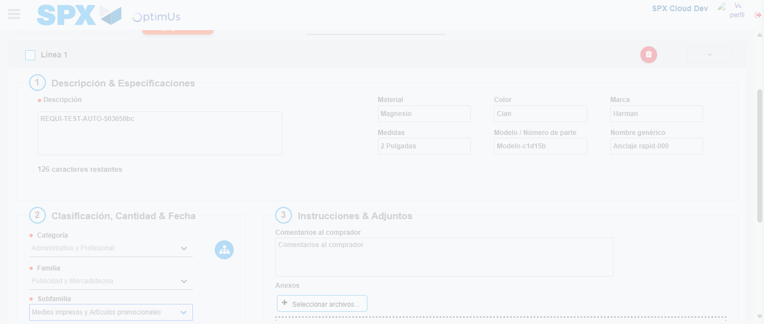Image file-name: QC_Testing-runTestMultipleTimes-dic. 04 2025, 03 53 18 p. m.

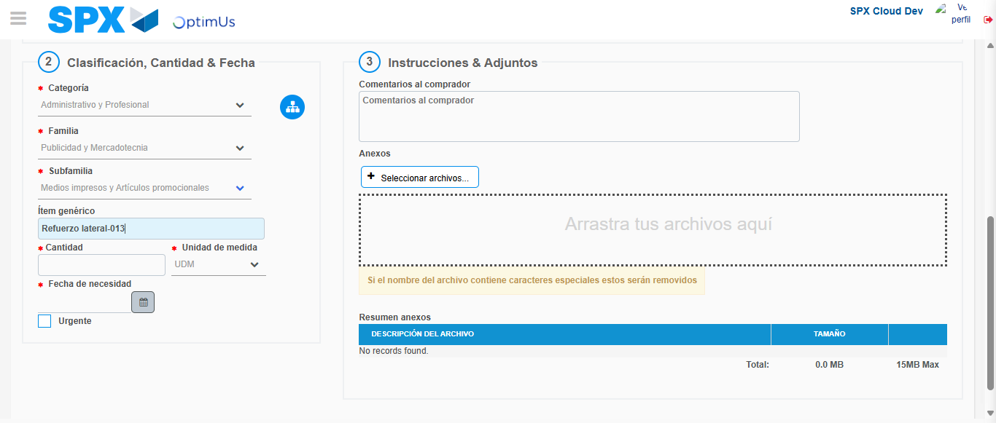Image file-name: QC_Testing-runTestMultipleTimes-dic. 04 2025, 03 53 20 p. m.

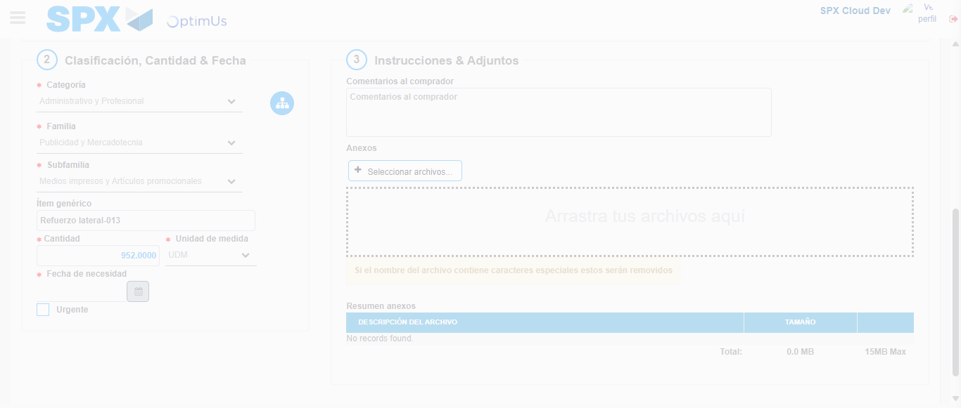Image file-name: QC_Testing-runTestMultipleTimes-dic. 04 2025, 03 53 21 p. m.

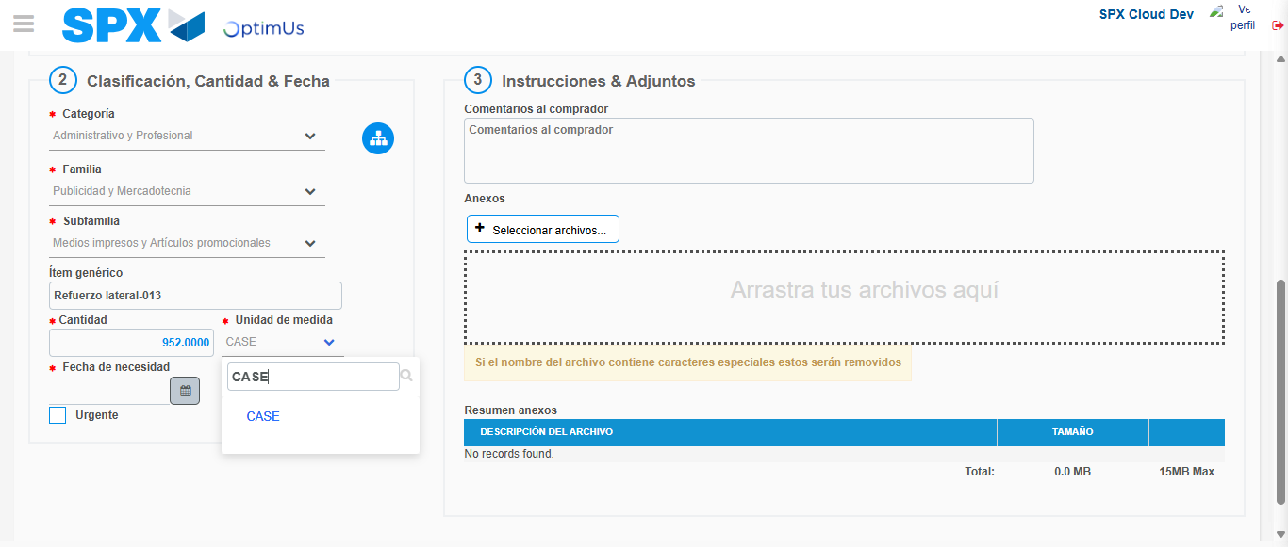Image file-name: QC_Testing-runTestMultipleTimes-dic. 04 2025, 03 53 22 p. m.

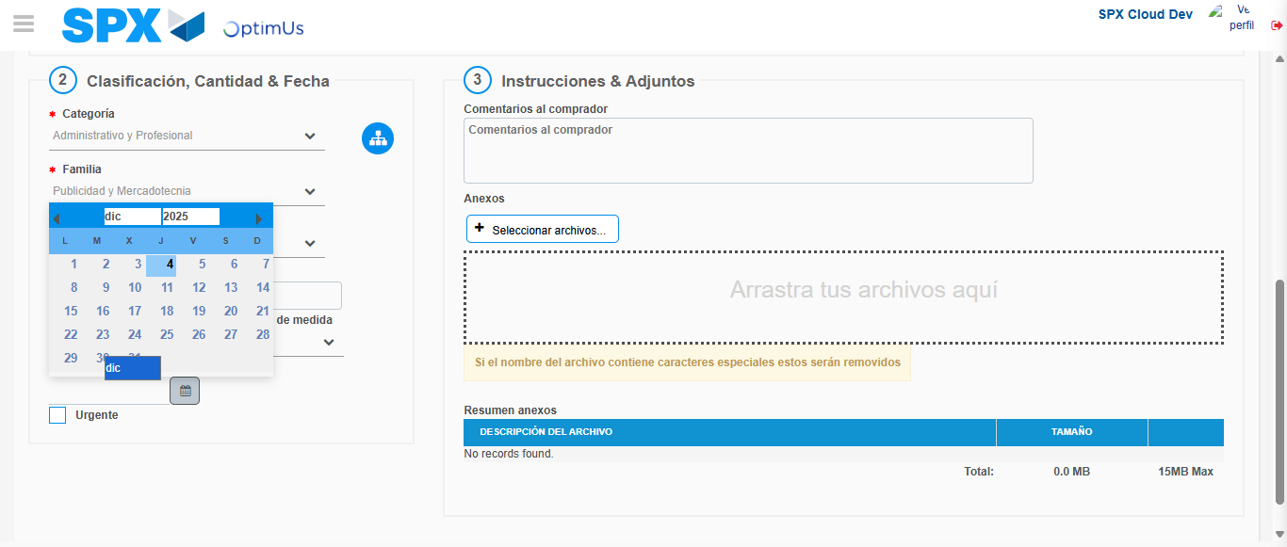Image file-name: QC_Testing-runTestMultipleTimes-dic. 04 2025, 03 53 23 p. m.

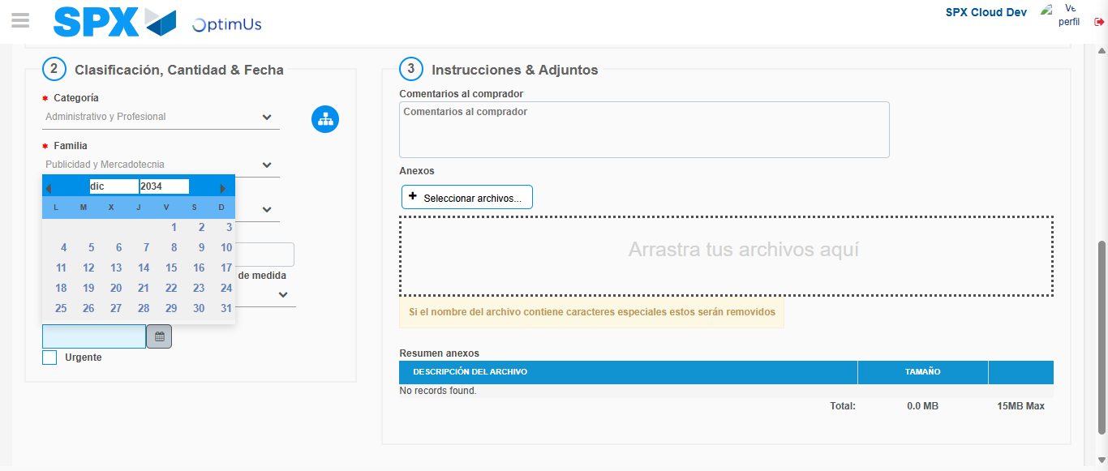Image file-name: QC_Testing-runTestMultipleTimes-dic. 04 2025, 03 53 24 p. m.

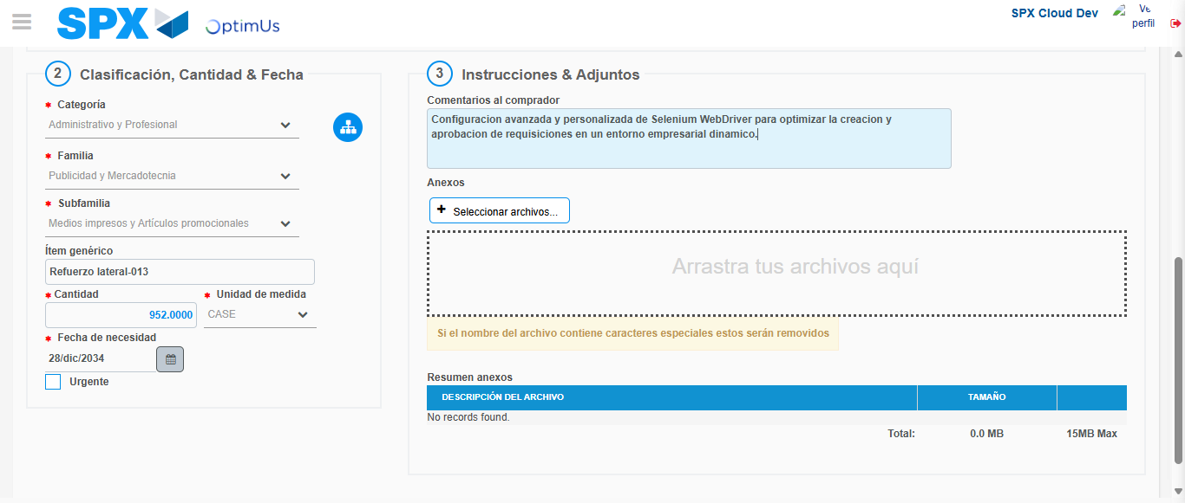Image file-name: QC_Testing-runTestMultipleTimes-dic. 04 2025, 03 53 25 p. m.

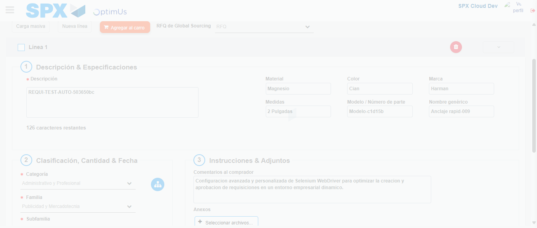Image file-name: QC_Testing-runTestMultipleTimes-dic. 04 2025, 03 53 26 p. m.

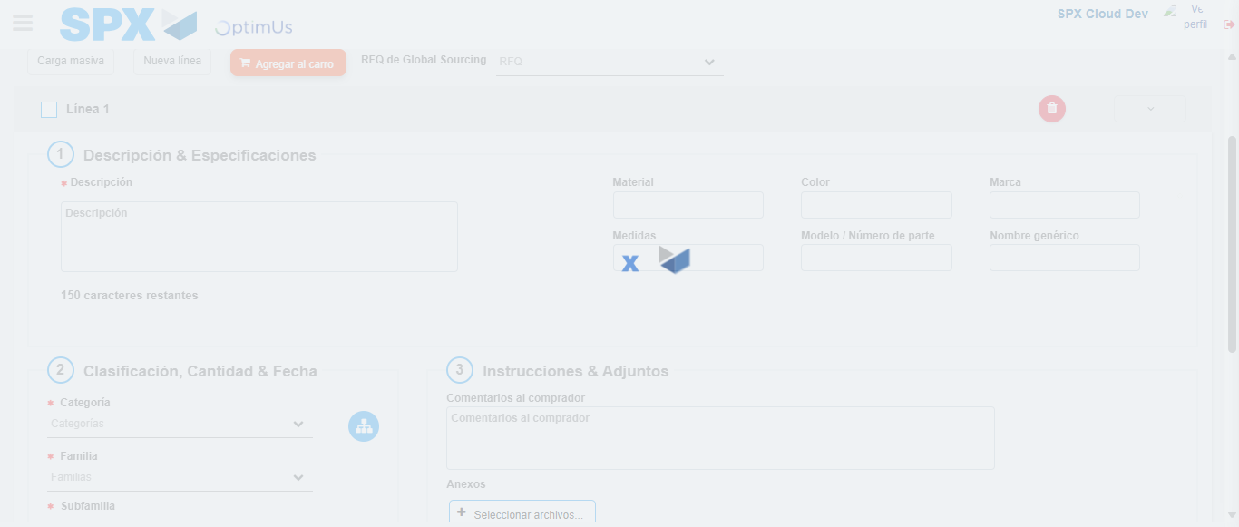Image file-name: QC_Testing-runTestMultipleTimes-dic. 04 2025, 03 53 30 p. m.

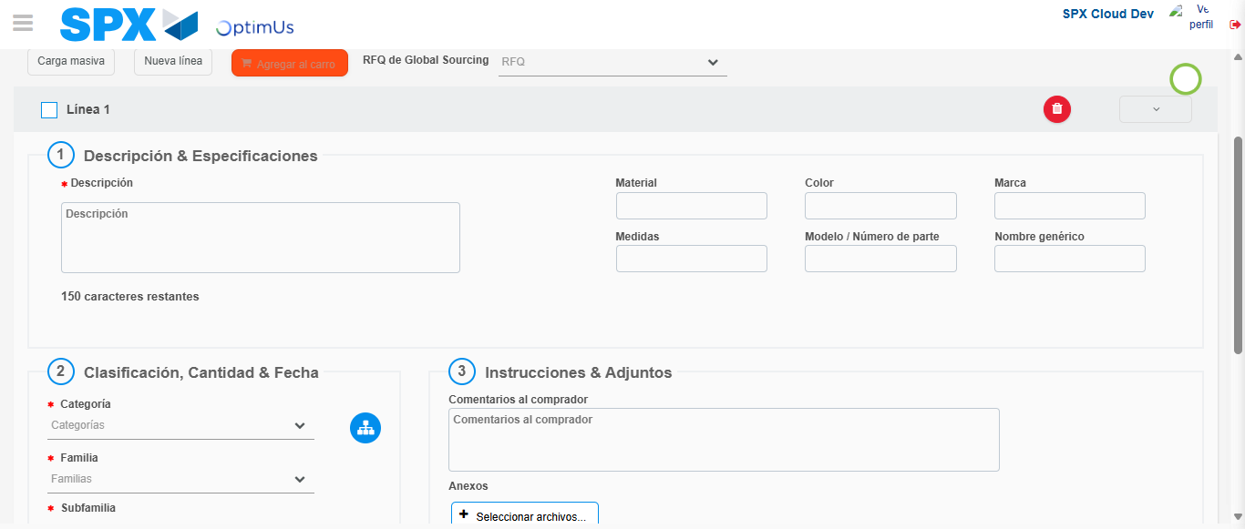Image file-name: QC_Testing-runTestMultipleTimes-dic. 04 2025, 03 53 31 p. m.

Image file-name: QC_Testing-runTestMultipleTimes-dic. 04 2025, 03 54 47 p. m.

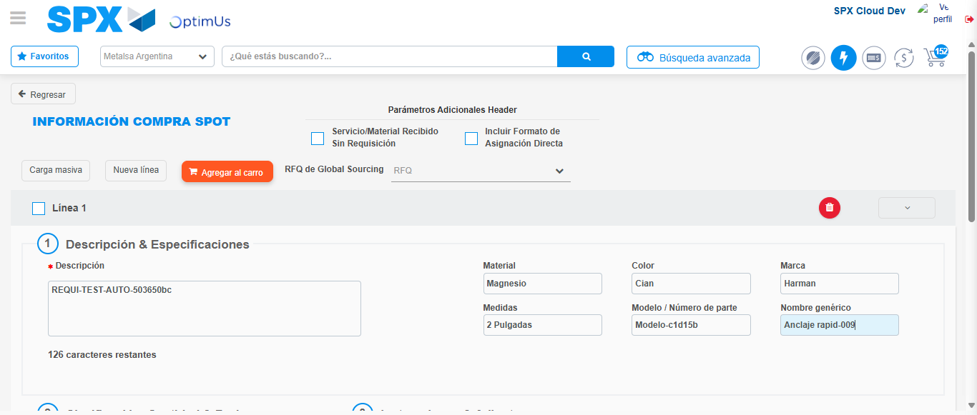Image file-name: QC_Testing-runTestMultipleTimes-dic. 04 2025, 03 54 48 p. m.

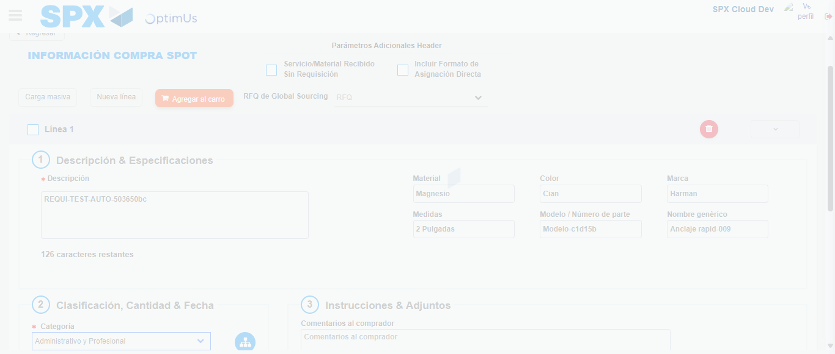Image file-name: QC_Testing-runTestMultipleTimes-dic. 04 2025, 03 54 49 p. m.

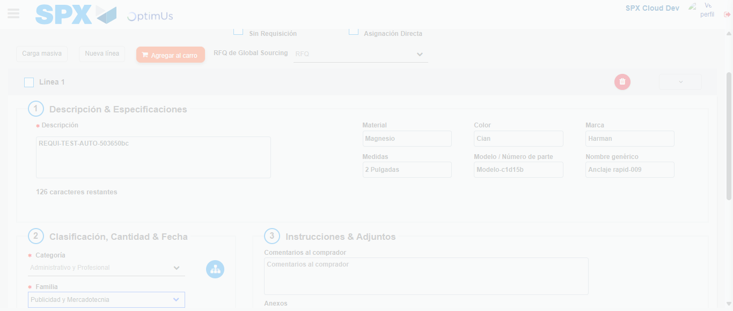Image file-name: QC_Testing-runTestMultipleTimes-dic. 04 2025, 03 54 50 p. m.

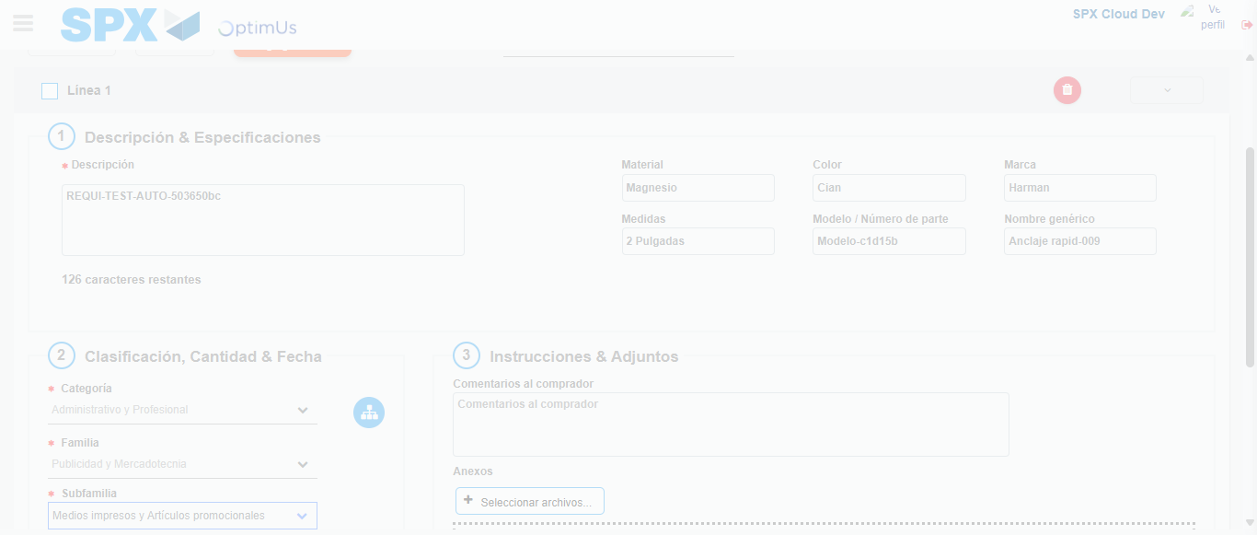Image file-name: QC_Testing-runTestMultipleTimes-dic. 04 2025, 03 54 51 p. m.

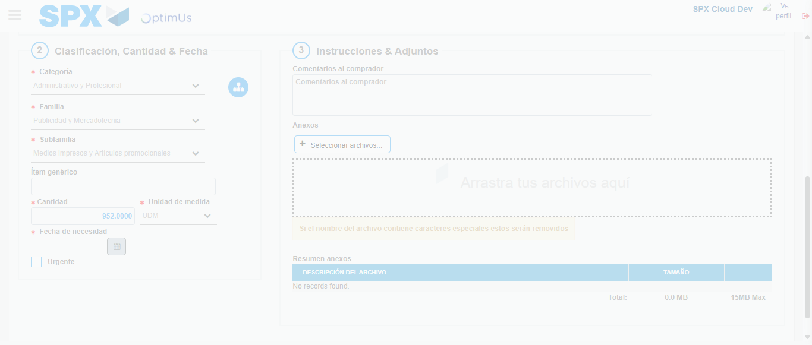Image file-name: QC_Testing-runTestMultipleTimes-dic. 04 2025, 03 54 52 p. m.

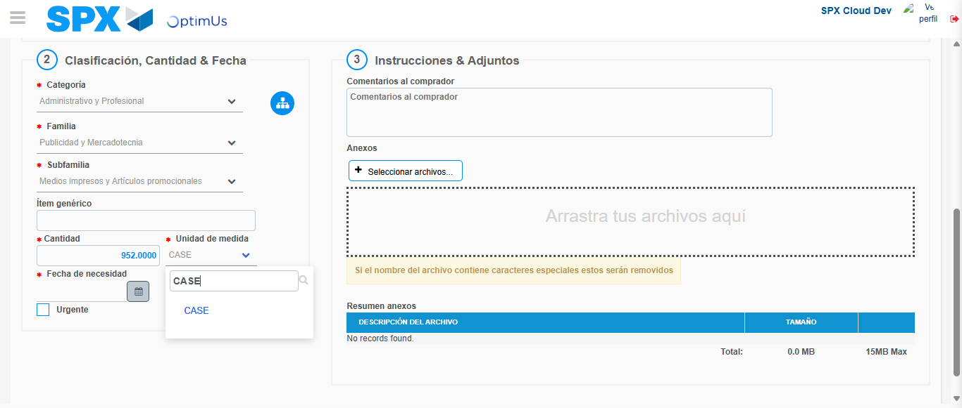Image file-name: QC_Testing-runTestMultipleTimes-dic. 04 2025, 03 54 53 p. m.

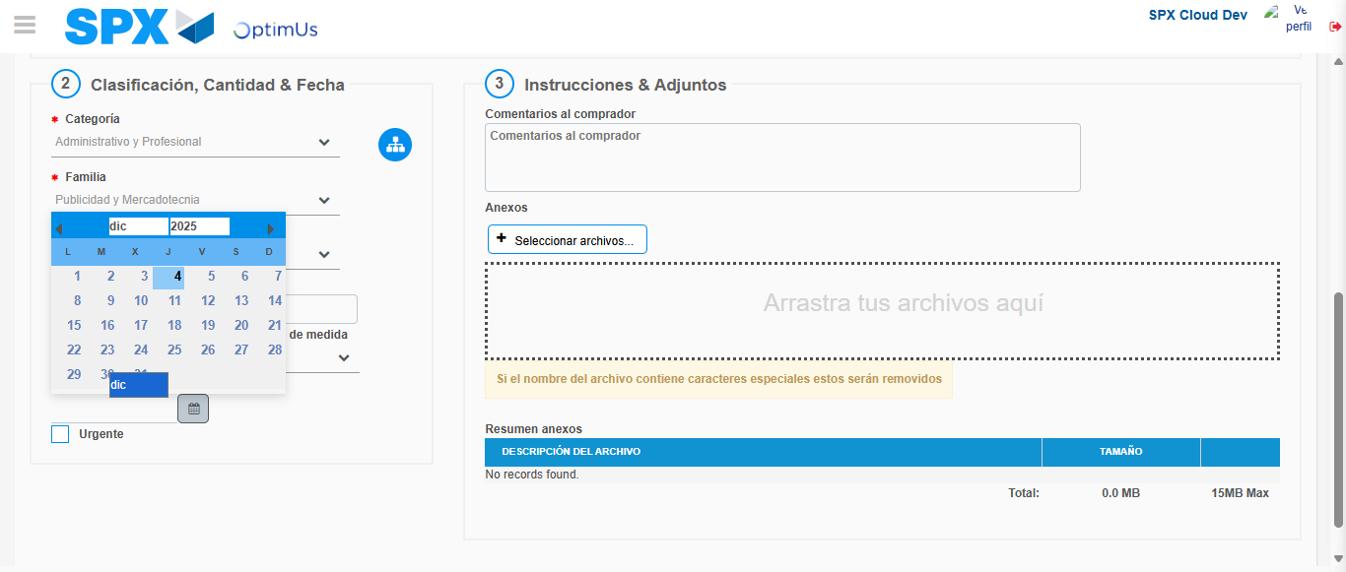Image file-name: QC_Testing-runTestMultipleTimes-dic. 04 2025, 03 54 54 p. m.

Image file-name: QC_Testing-runTestMultipleTimes-dic. 04 2025, 03 54 55 p. m.

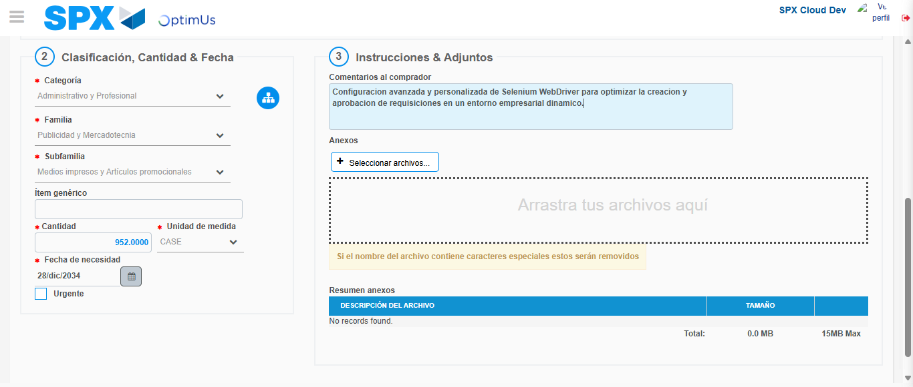Image file-name: QC_Testing-runTestMultipleTimes-dic. 04 2025, 03 54 56 p. m.

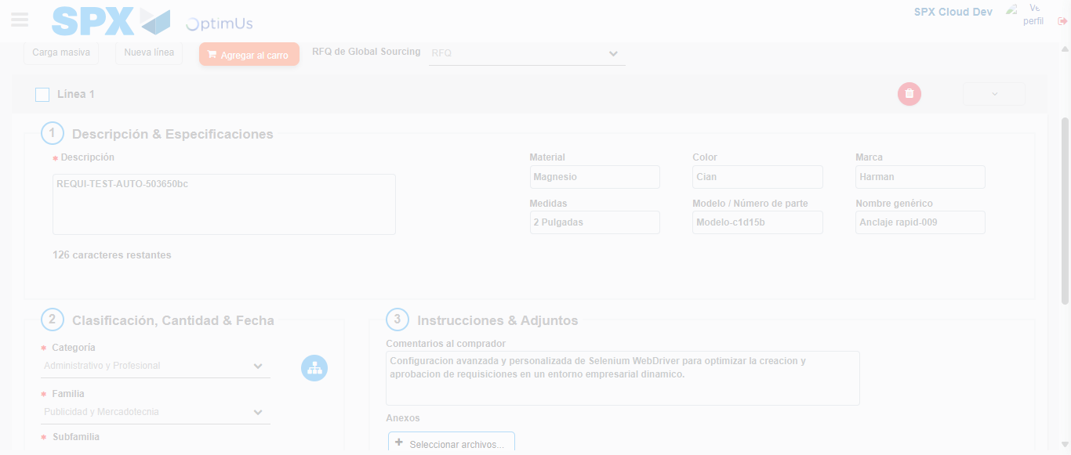Image file-name: QC_Testing-runTestMultipleTimes-dic. 04 2025, 03 54 57 p. m.

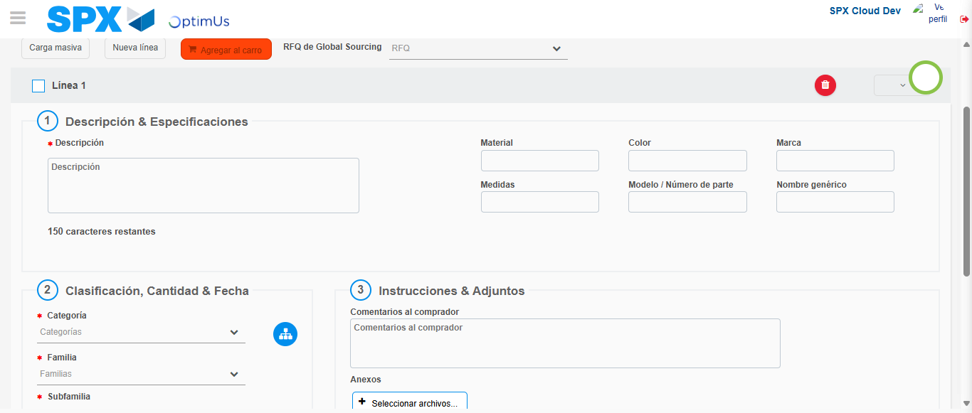Image file-name: QC_Testing-runTestMultipleTimes-dic. 04 2025, 03 55 05 p. m.

Step 4 - Select to Requisition : Requisition Correctly selected
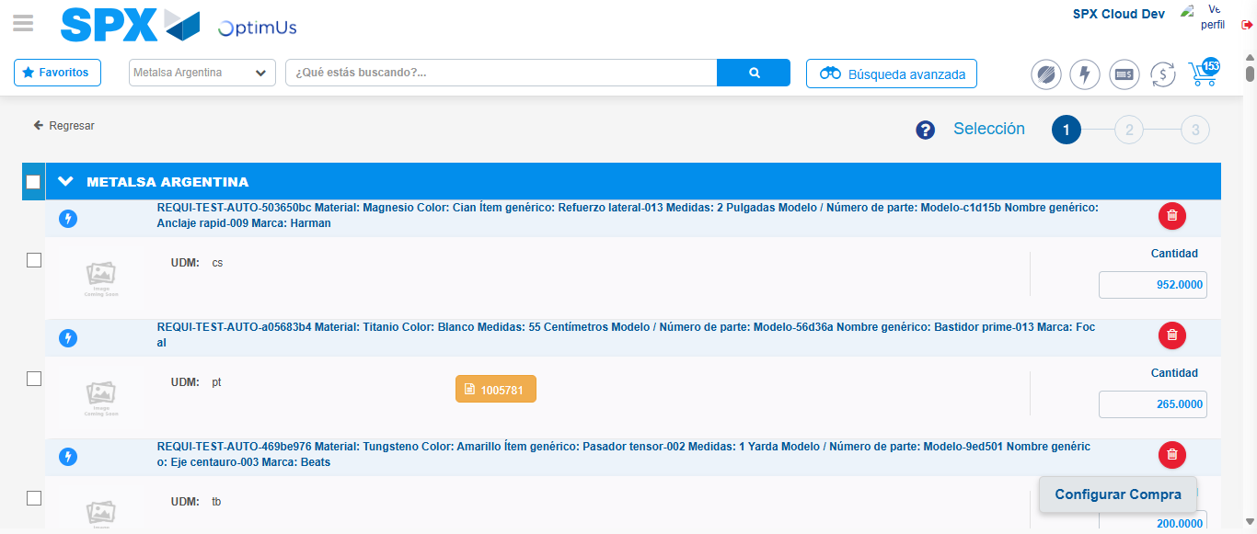Image file-name: QC_Testing-runTestMultipleTimes-dic. 04 2025, 03 53 42 p. m.

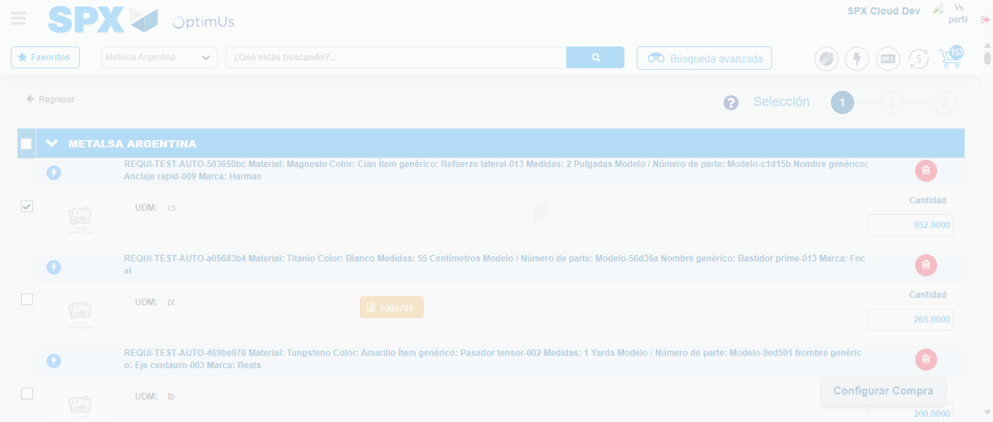Image file-name: QC_Testing-runTestMultipleTimes-dic. 04 2025, 03 53 43 p. m.

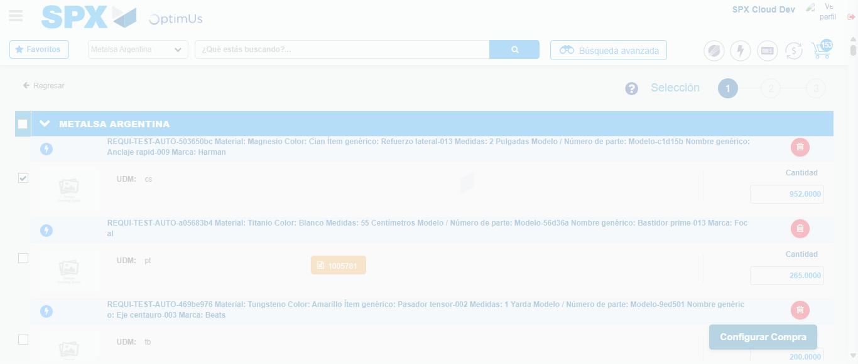Image file-name: QC_Testing-runTestMultipleTimes-dic. 04 2025, 03 53 46 p. m.

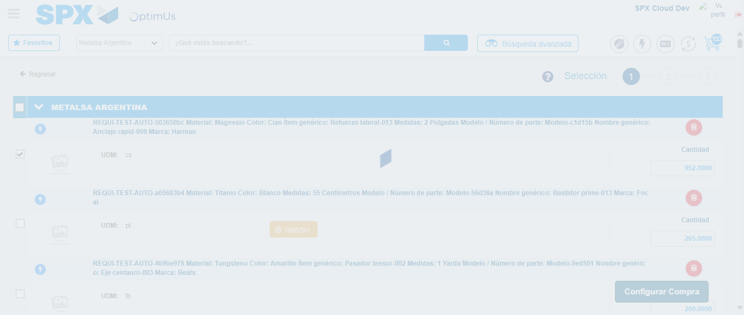Image file-name: QC_Testing-runTestMultipleTimes-dic. 04 2025, 03 53 47 p. m.

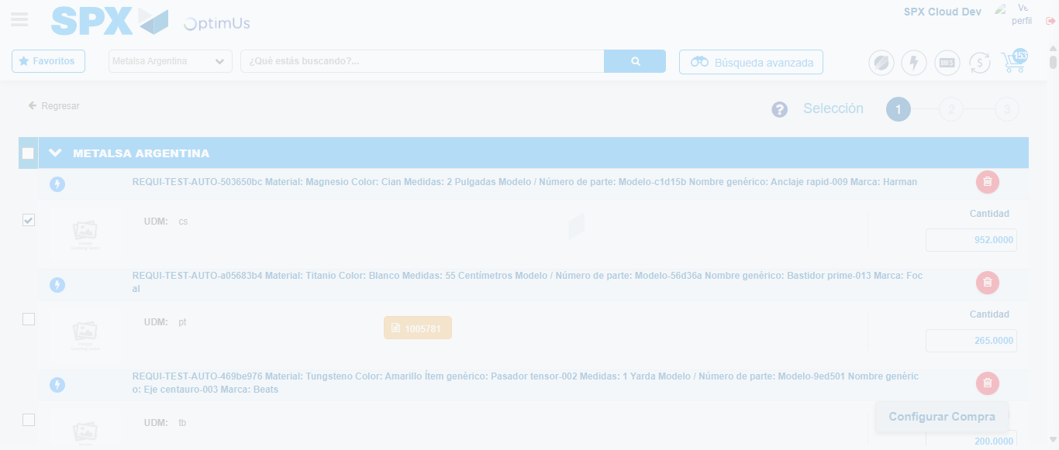Image file-name: QC_Testing-runTestMultipleTimes-dic. 04 2025, 03 55 14 p. m.

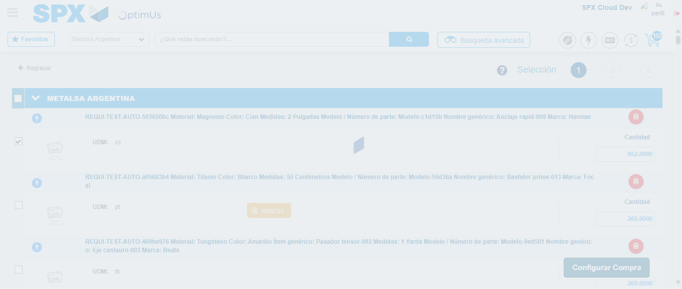Image file-name: QC_Testing-runTestMultipleTimes-dic. 04 2025, 03 55 18 p. m.

Step 5 - Select Type Account For Requisition : Type Account Correctly selected
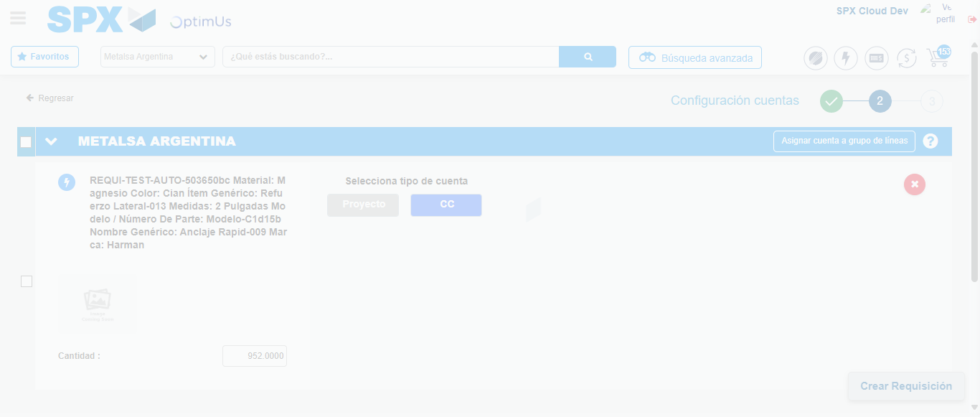Image file-name: QC_Testing-runTestMultipleTimes-dic. 04 2025, 03 53 50 p. m.

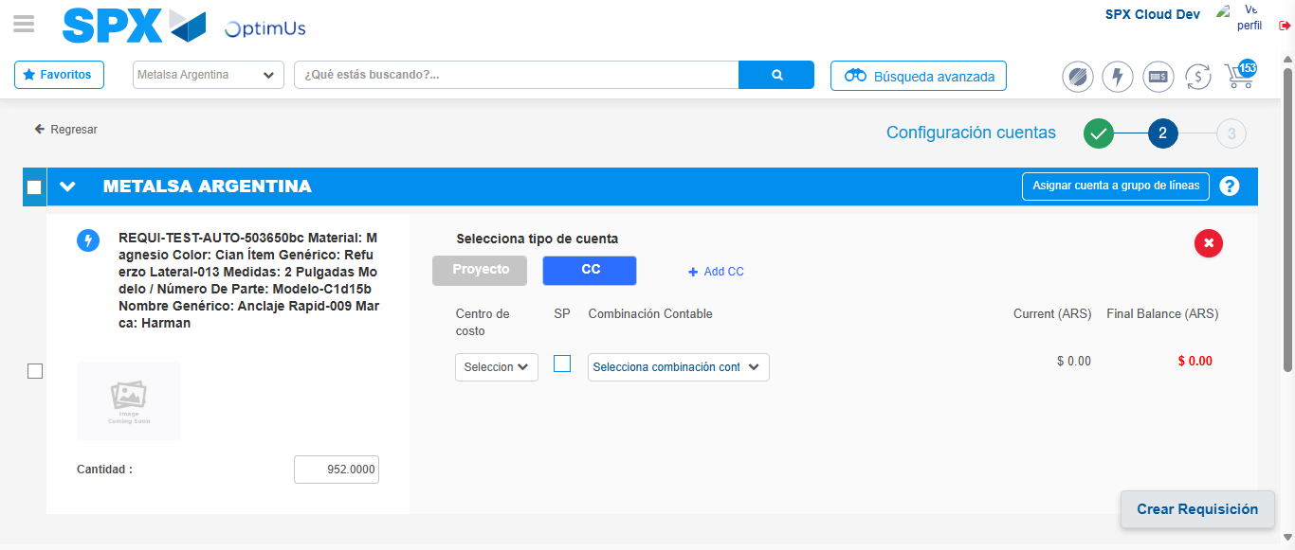Image file-name: QC_Testing-runTestMultipleTimes-dic. 04 2025, 03 53 53 p. m.

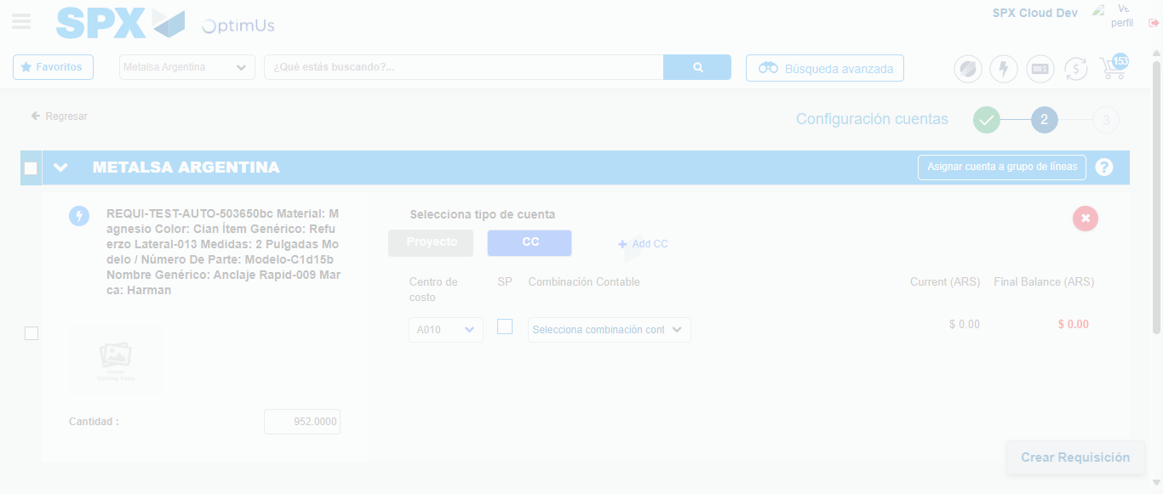Image file-name: QC_Testing-runTestMultipleTimes-dic. 04 2025, 03 53 57 p. m.

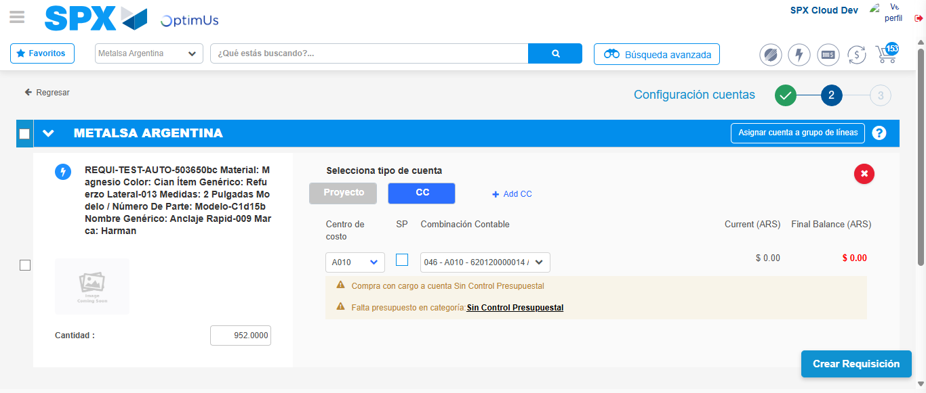Image file-name: QC_Testing-runTestMultipleTimes-dic. 04 2025, 03 54 00 p. m.

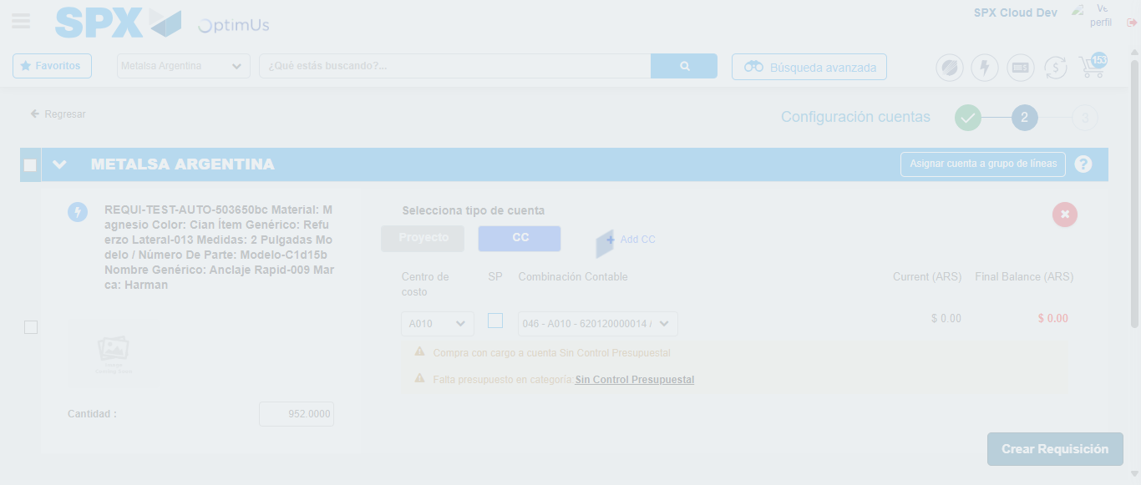Image file-name: QC_Testing-runTestMultipleTimes-dic. 04 2025, 03 54 01 p. m.

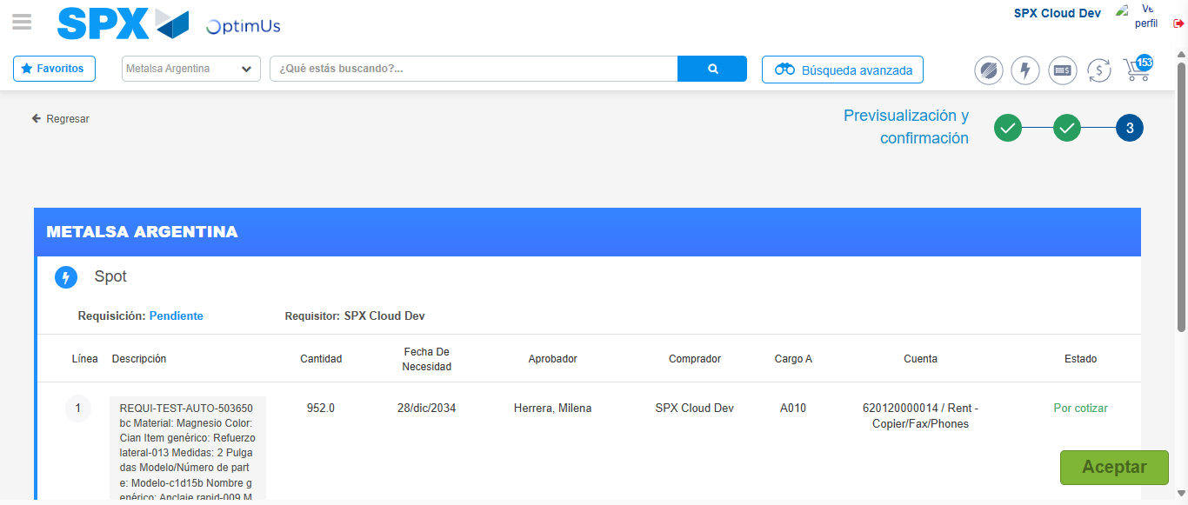Image file-name: QC_Testing-runTestMultipleTimes-dic. 04 2025, 03 54 04 p. m.

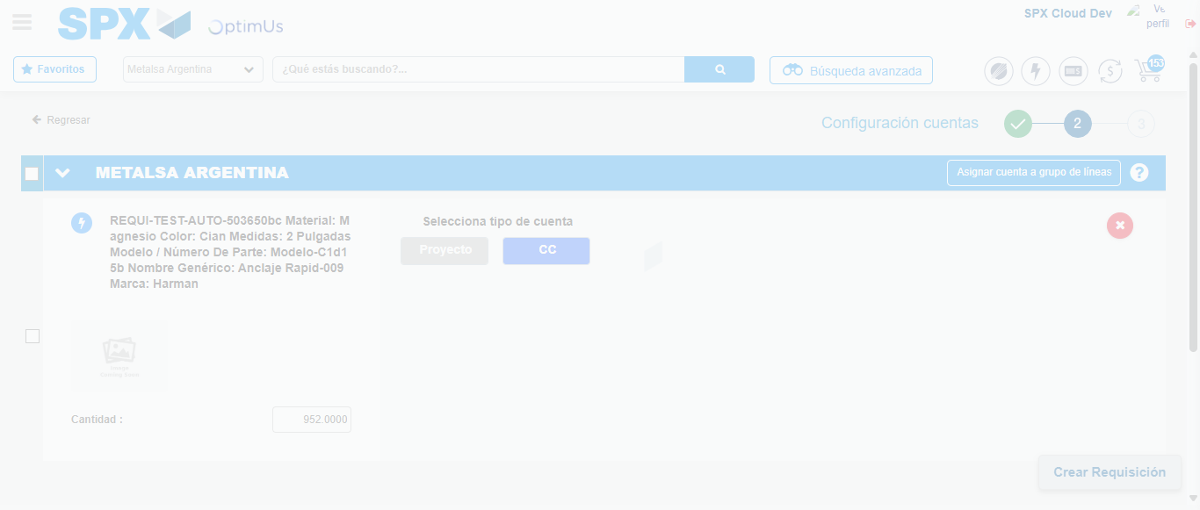Image file-name: QC_Testing-runTestMultipleTimes-dic. 04 2025, 03 55 21 p. m.

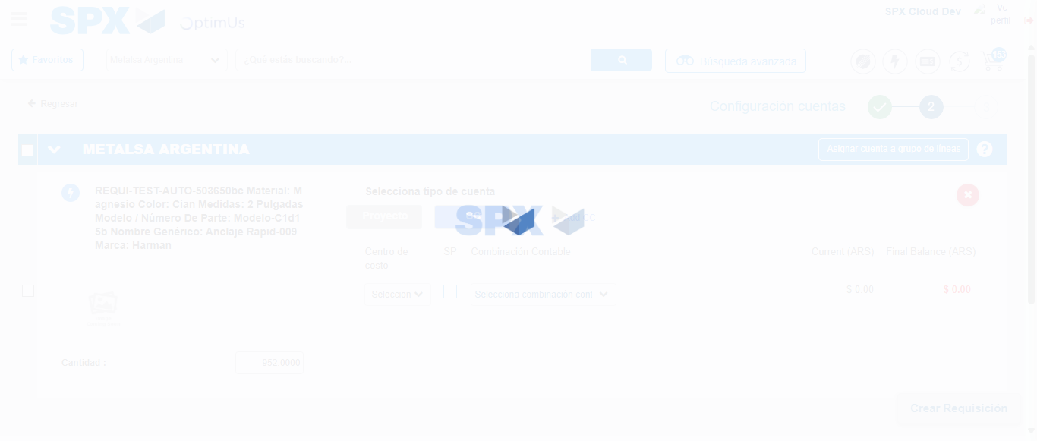Image file-name: QC_Testing-runTestMultipleTimes-dic. 04 2025, 03 55 24 p. m.

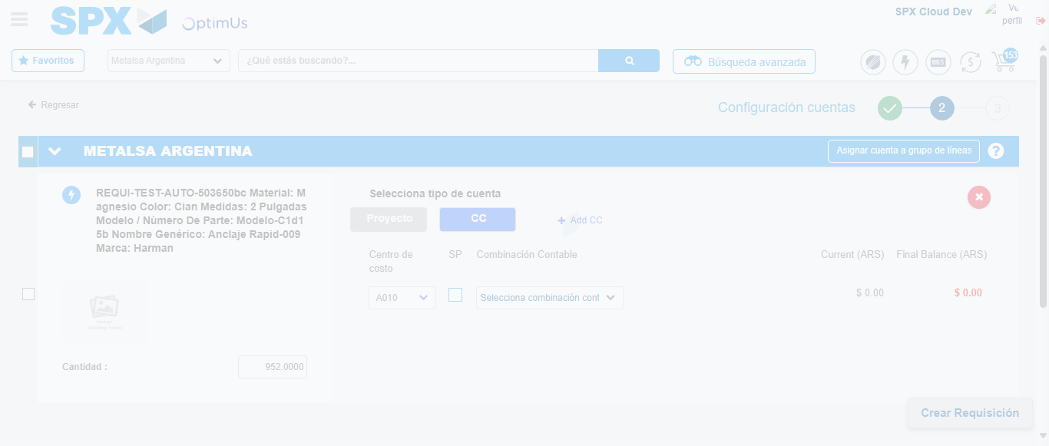Image file-name: QC_Testing-runTestMultipleTimes-dic. 04 2025, 03 55 28 p. m.

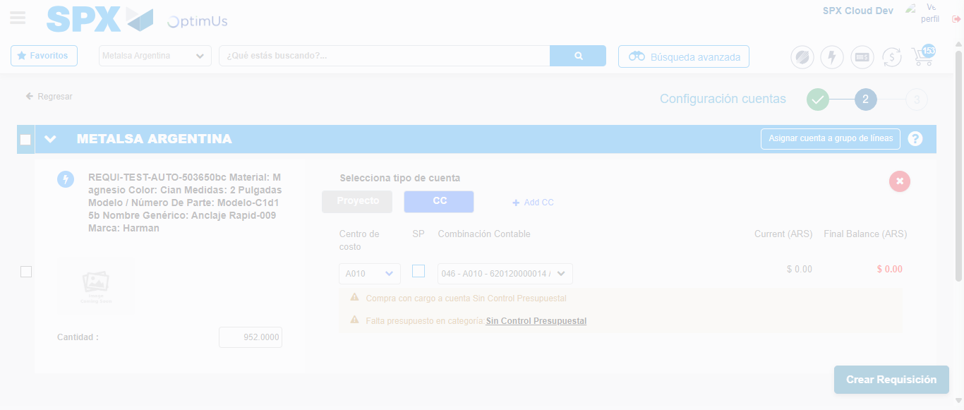Image file-name: QC_Testing-runTestMultipleTimes-dic. 04 2025, 03 55 31 p. m.

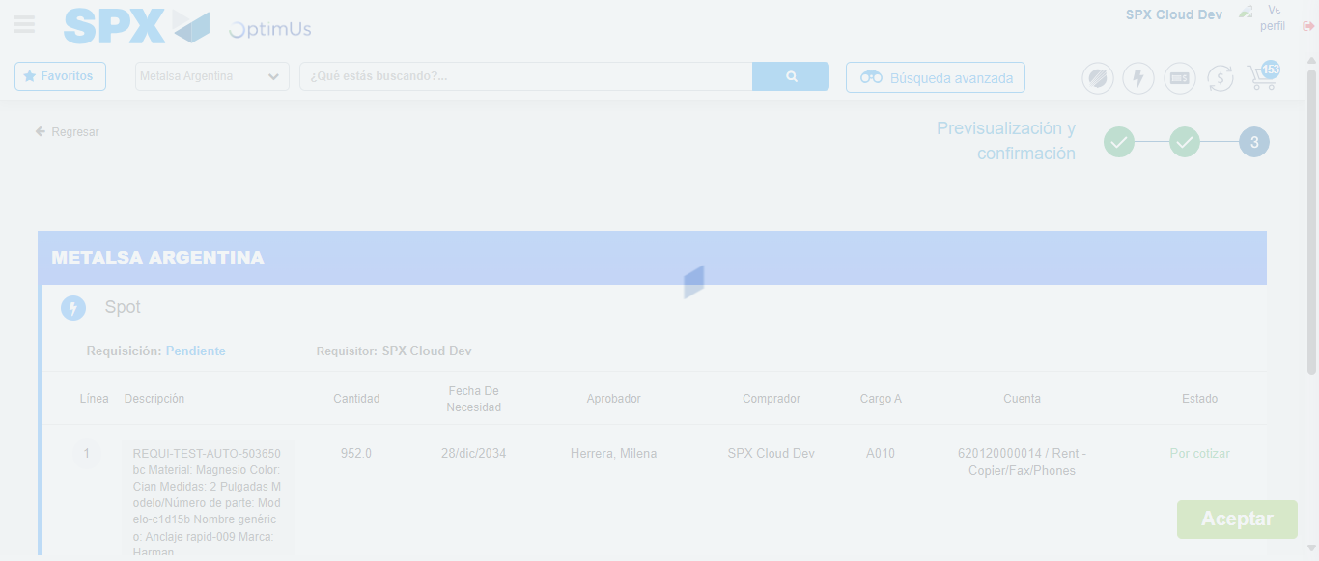Image file-name: QC_Testing-runTestMultipleTimes-dic. 04 2025, 03 55 32 p. m.

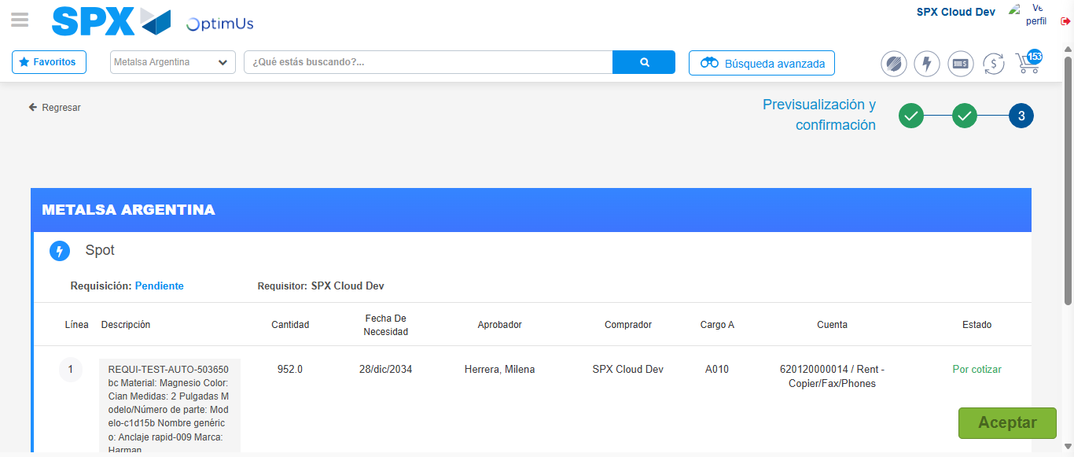Image file-name: QC_Testing-runTestMultipleTimes-dic. 04 2025, 03 55 35 p. m.

Step 6 - Accept to Requisition : Requisition Accepted
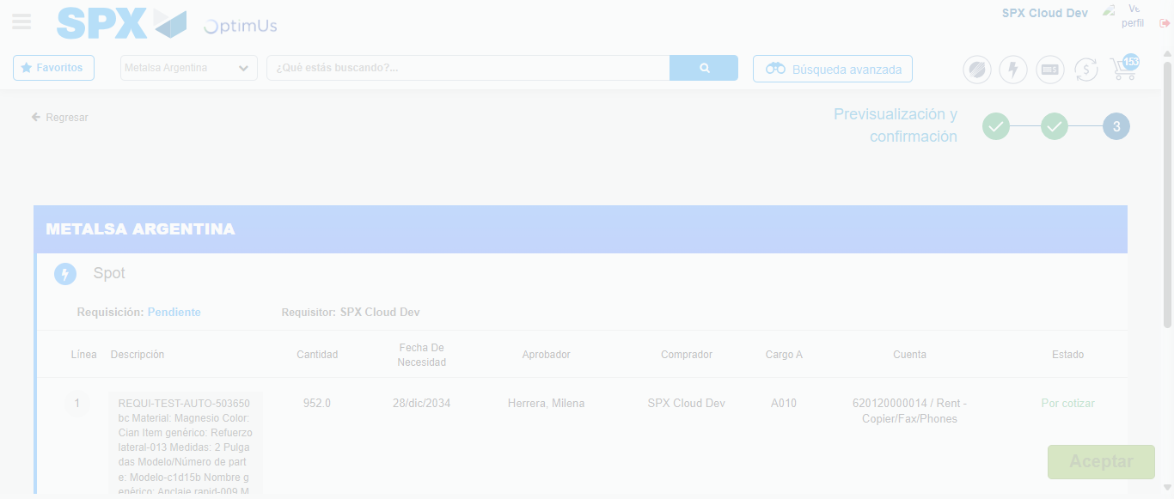Image file-name: QC_Testing-runTestMultipleTimes-dic. 04 2025, 03 54 05 p. m.

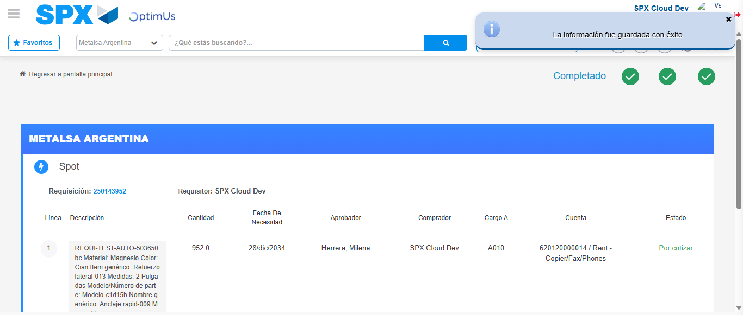Image file-name: QC_Testing-runTestMultipleTimes-dic. 04 2025, 03 54 08 p. m.

Image file-name: QC_Testing-runTestMultipleTimes-dic. 04 2025, 03 55 35 p. m.

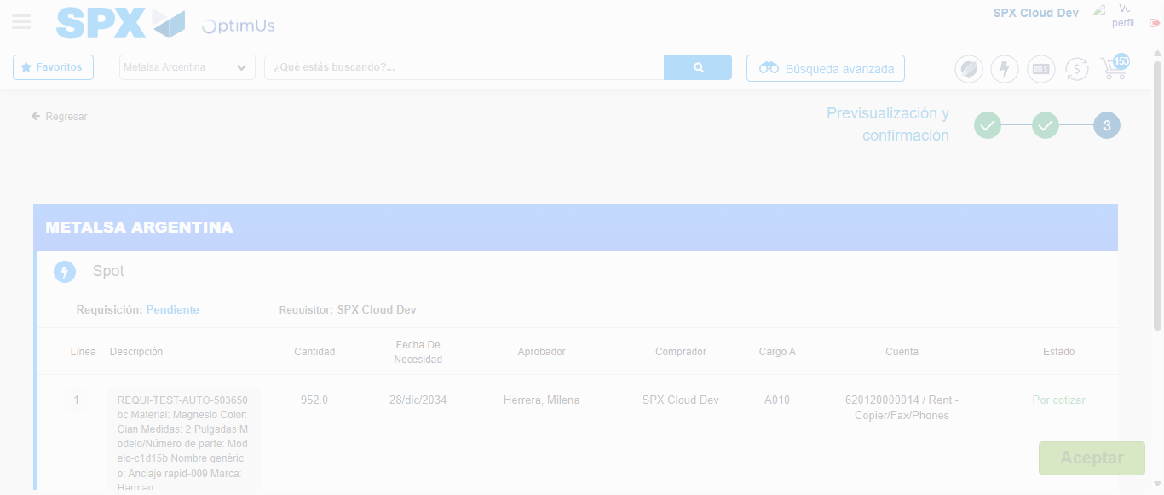Image file-name: QC_Testing-runTestMultipleTimes-dic. 04 2025, 03 55 36 p. m.

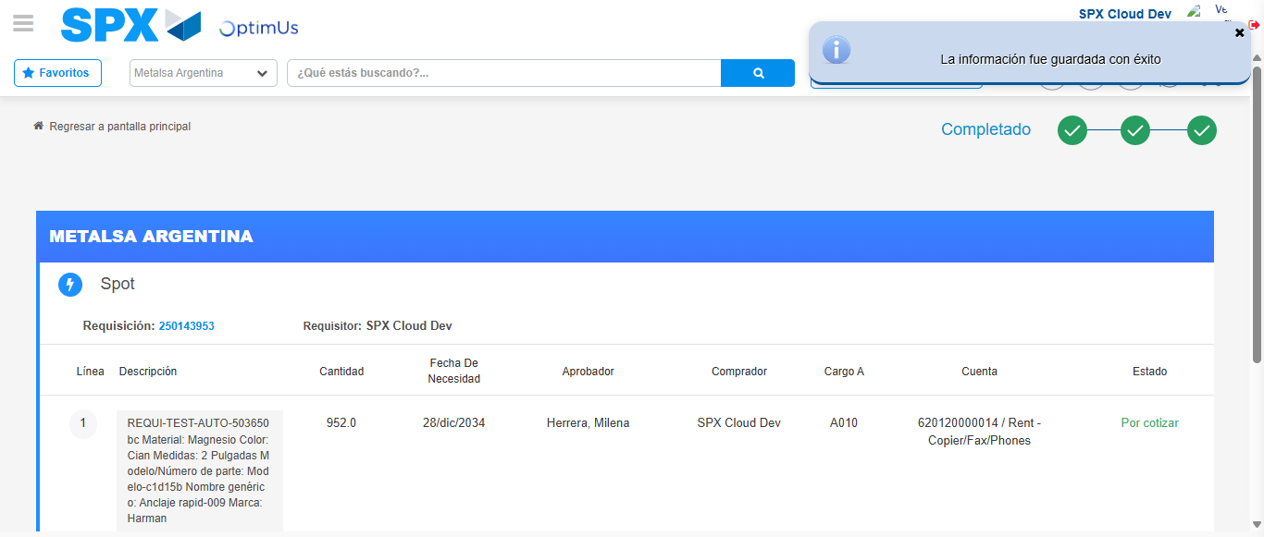Image file-name: QC_Testing-runTestMultipleTimes-dic. 04 2025, 03 55 39 p. m.

